

**Research Project**

**Trade: ICT Software Applications**

**Qualification: ICT60115 Advanced Diploma of Information Technology**

**Cluster title: Research Project**

The following units listed are clustered together for learning purposes

|  |  |  |  |  |
| --- | --- | --- | --- | --- |
| ICTWEB516 Research and apply emerging web technology trends  ICTICT515 Verify client business requirements |  |  |  | 30 |

**Hotel Room Booking System**

**Instructions to candidate**

1. Read tasks carefully
2. Complete the all parts to the task described in this booklet
3. Attach a completed assignment coversheet when submitting each part

**TASK**

**Client requirements**

A company owns 3 hotels located in one city. The company decides to develop an online room booking system with the following functionality:

* The system database contains the following information:
  + Rooms – number of beds, a floor, availability dates, price with a discounted price for children
  + Clients – name, date of birth, gender, address, email, phone number, check-in and check-out dates
* The system must have the following functionality implemented:
  + A client’s account. A client must be logged in to book a room.
  + Search by room type for one or all hotels, price range, a hotel
  + Search by available rooms
  + Display client’s details

The system must be developed in ASP.NET Web Forms.

ER diagram

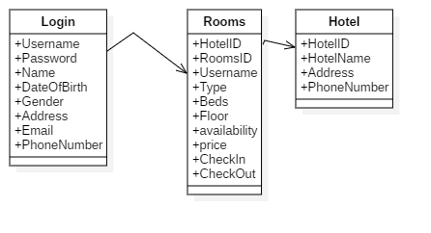

Database Schema

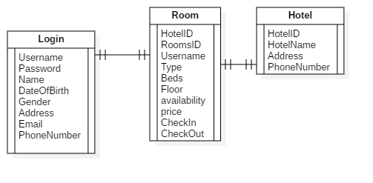

GUI Presentation

Home Page

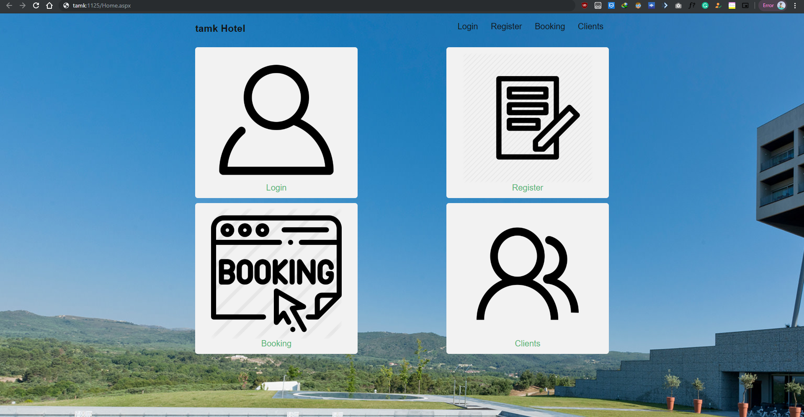

Login Page

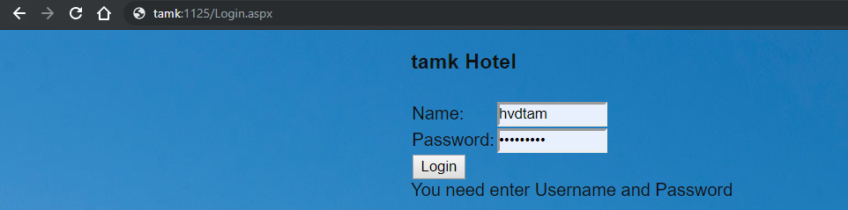

Register Page

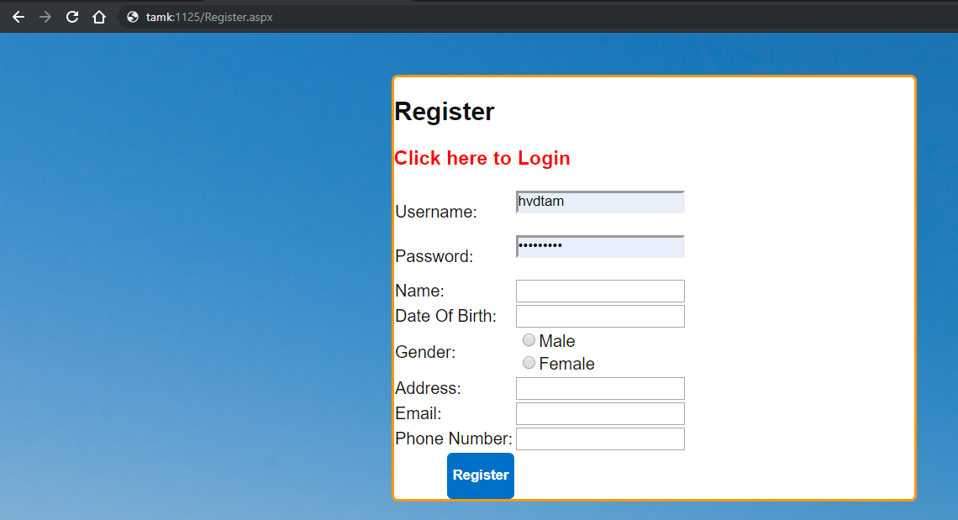

Booking Page

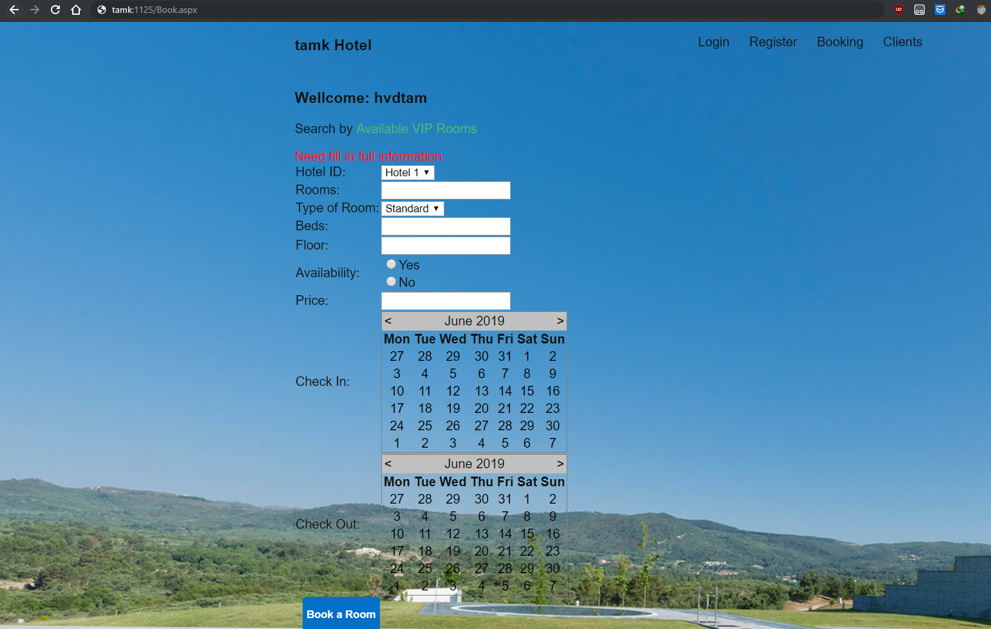

Clients Page

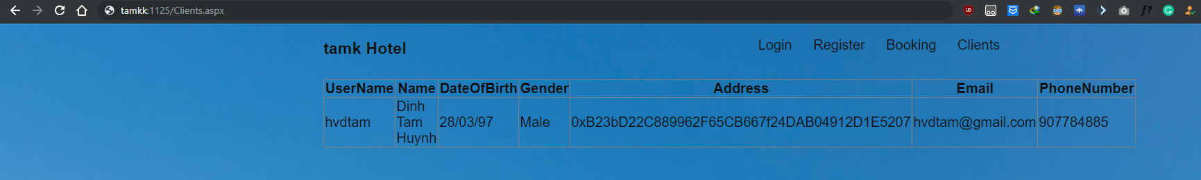

Coding style

Booking.aspx

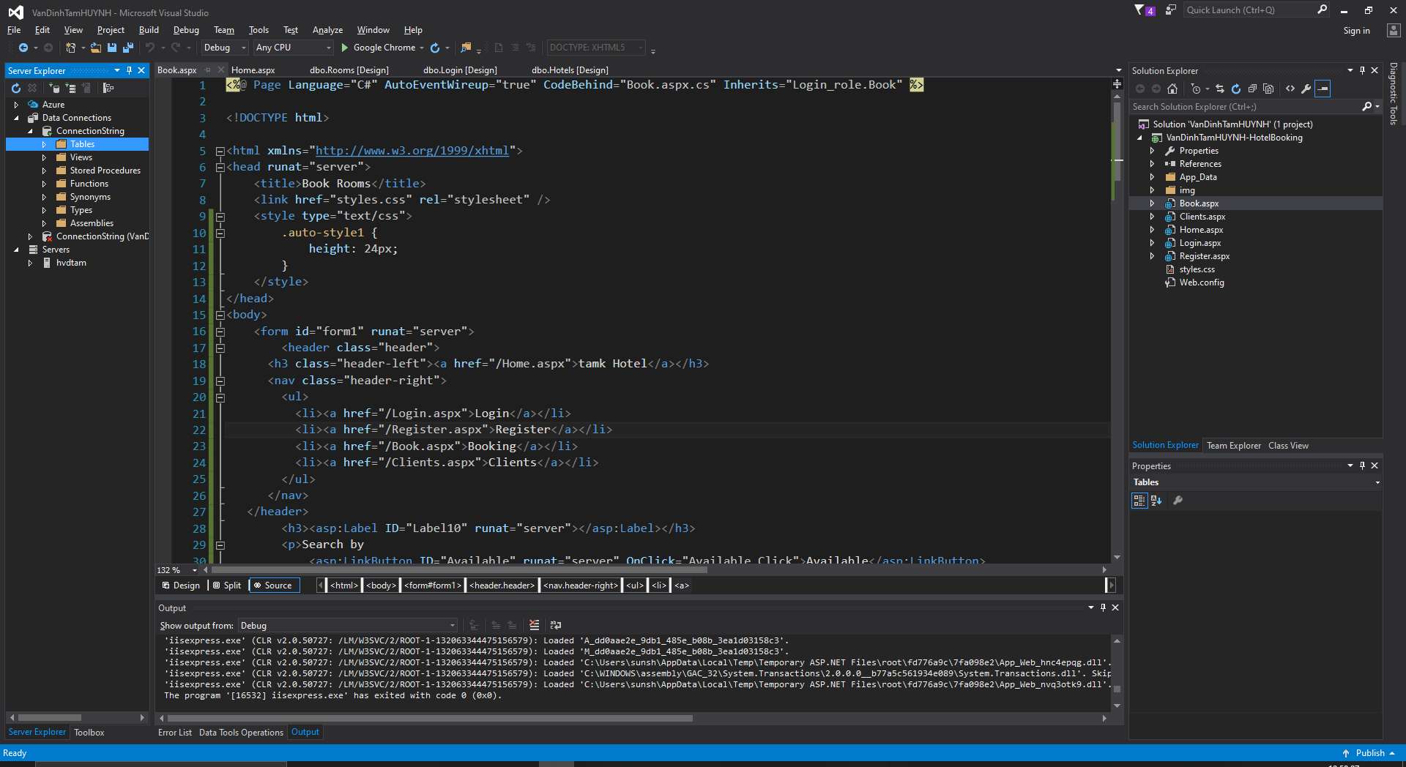

Clients.aspx

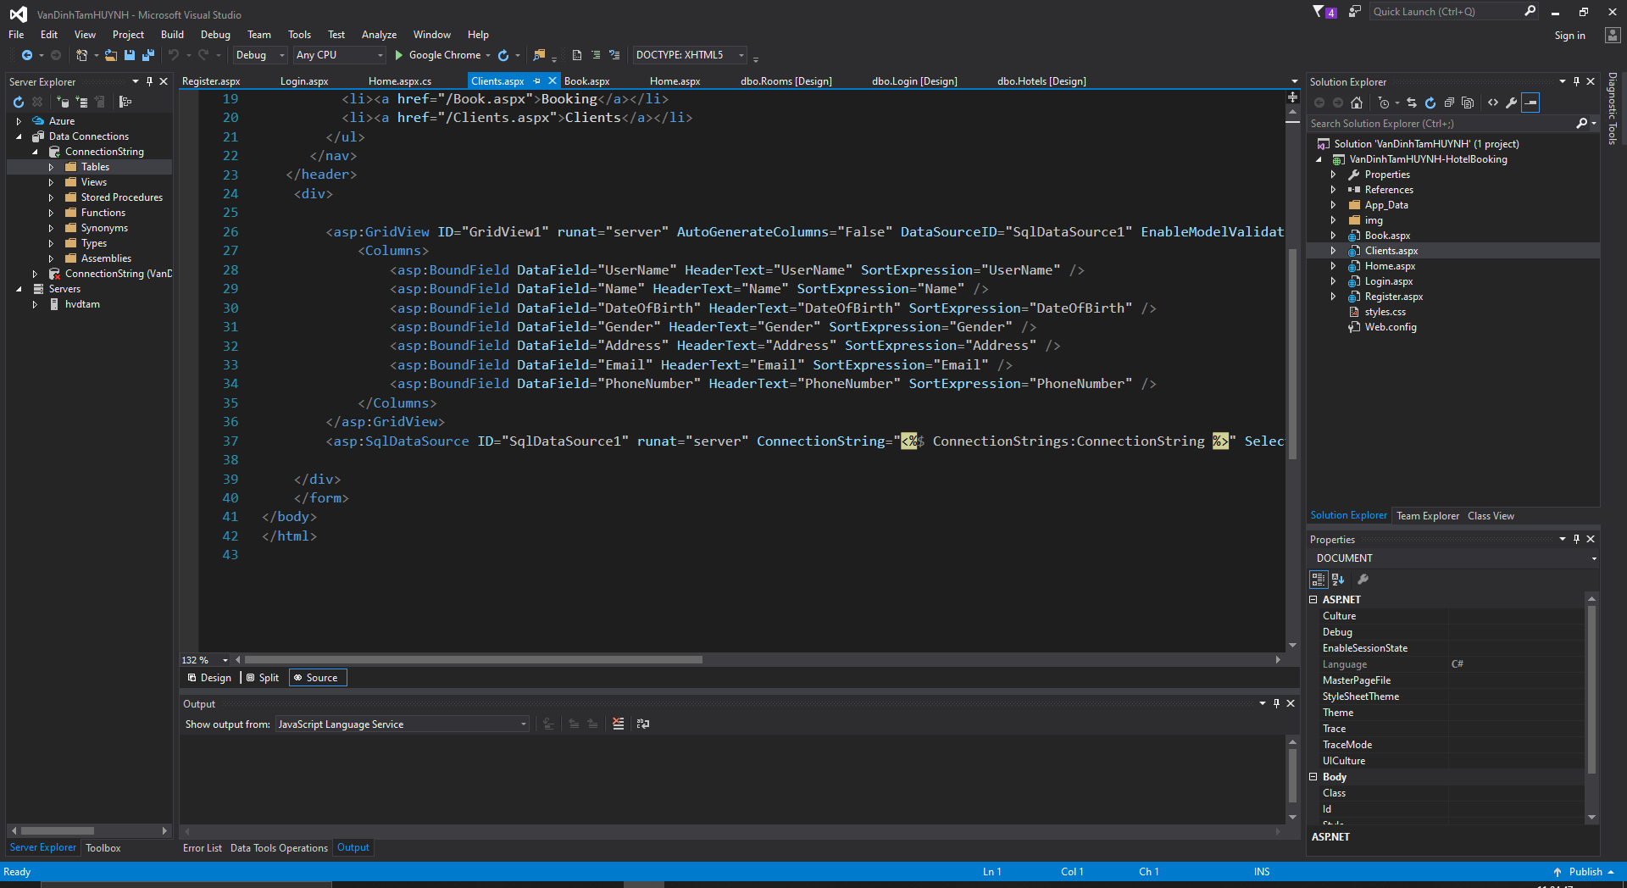

Home.aspx

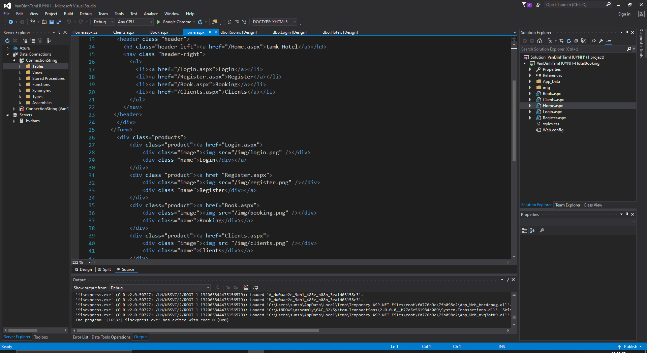

Login.aspx

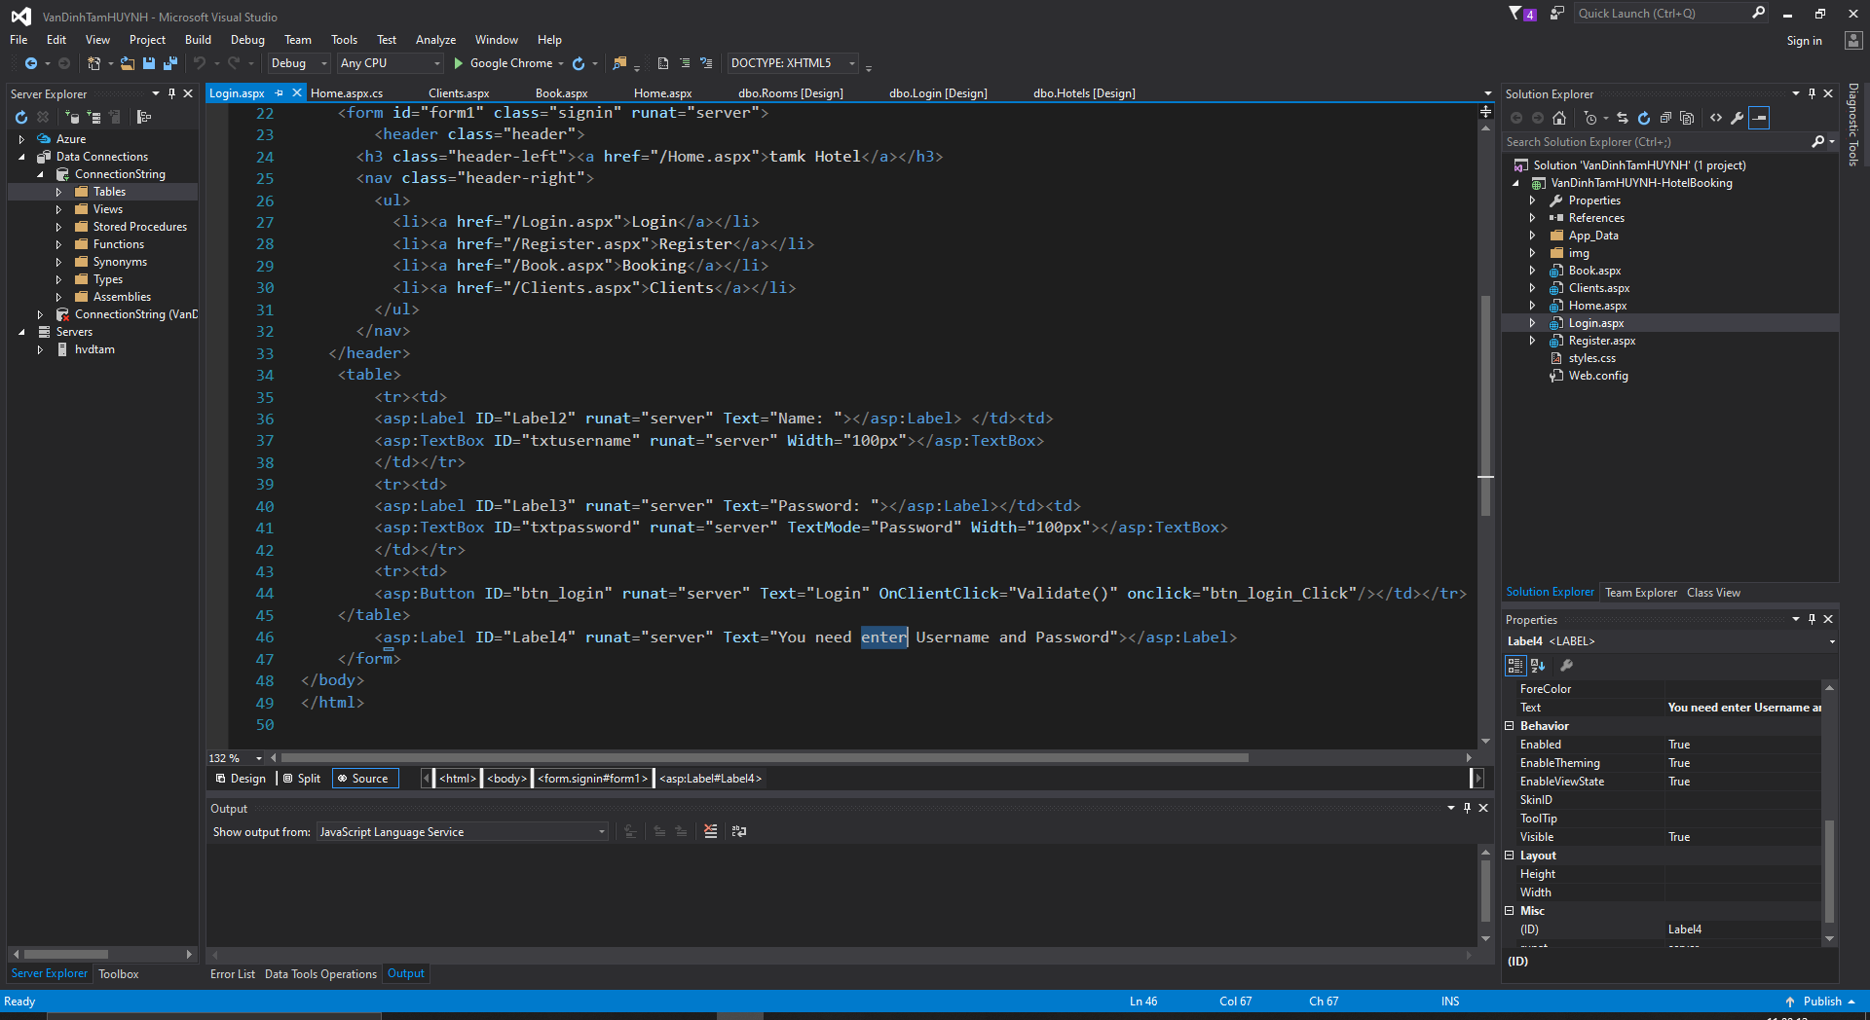

Register.aspx

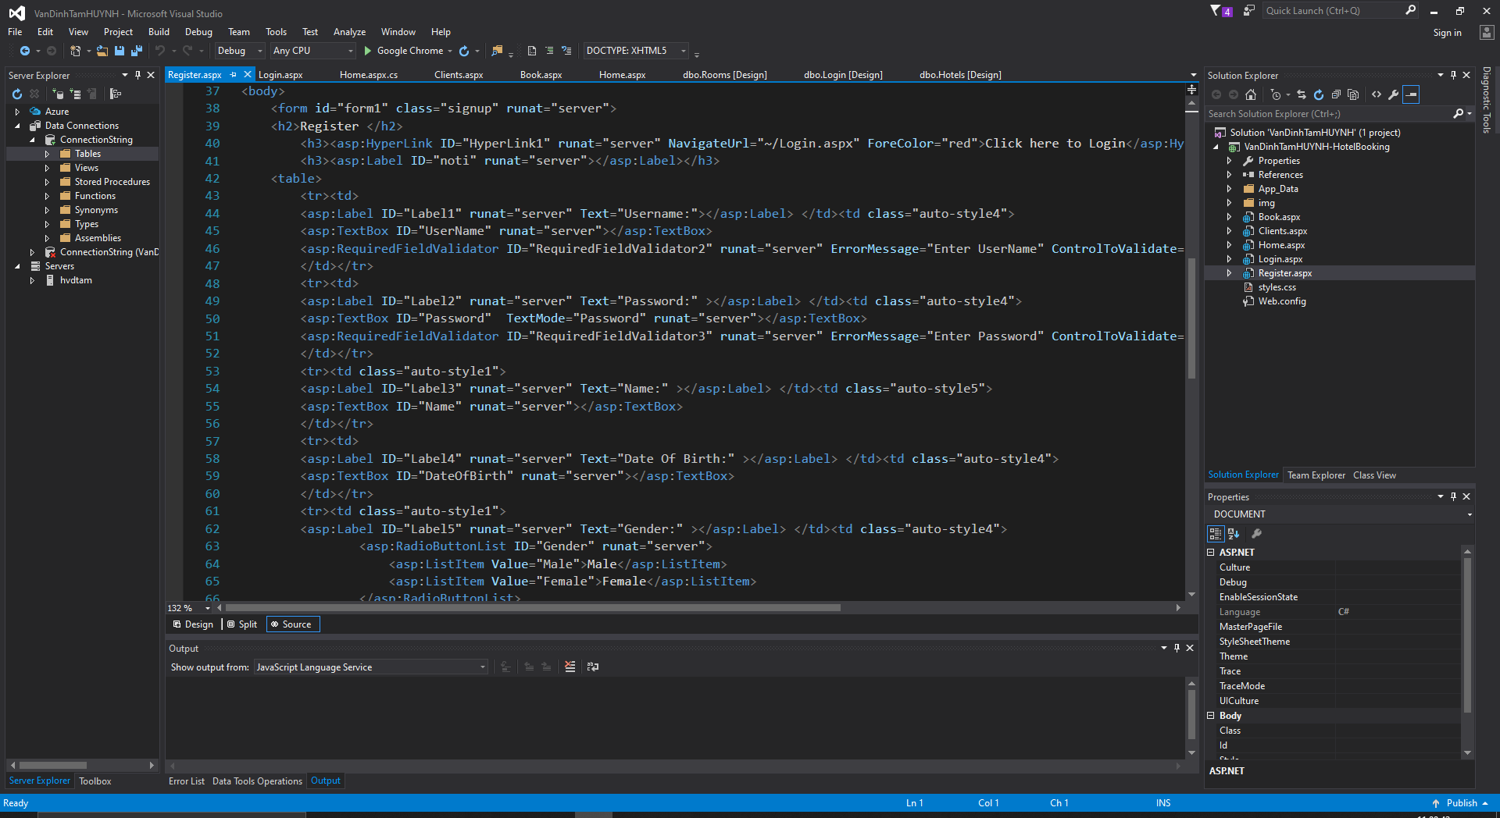

Functionally

Book.aspx

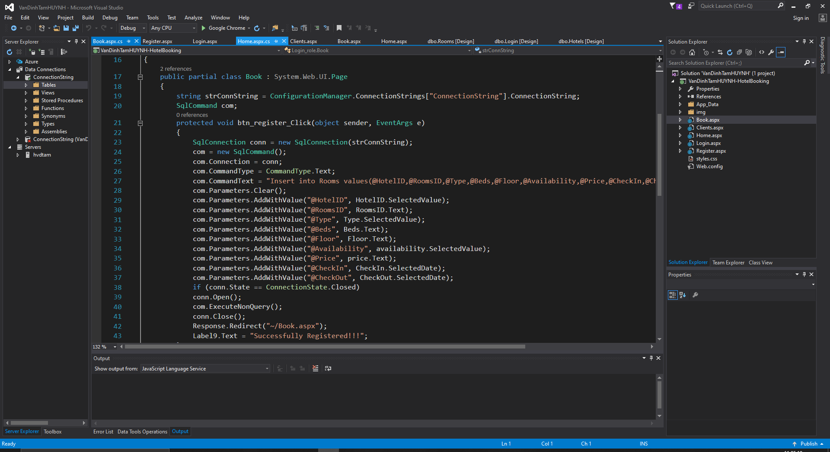

Login.aspx

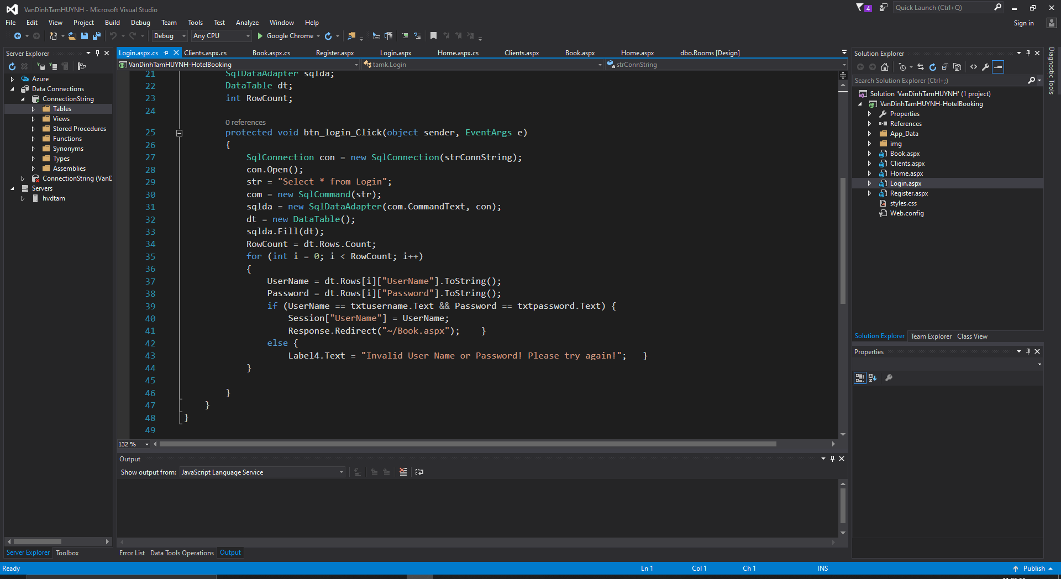

Register.aspx

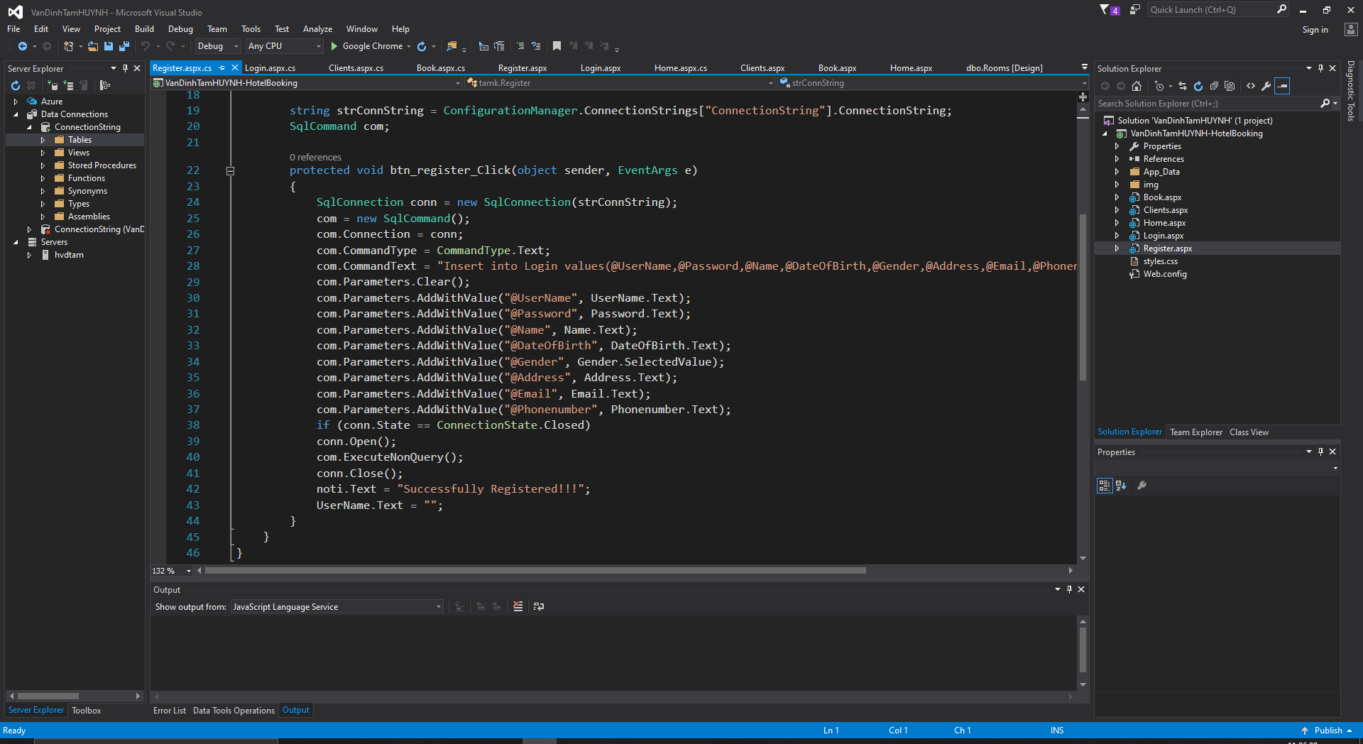

**This assignment is worth 40% of your total marks for the cluster.**

## 

**Assessment Cover sheet**

|  |  |
| --- | --- |
| Candidate name | Van Dinh Tam HUYNH |
| Trade | 201805806 |
| Assessment item title |  |
| Candidate email | [hvdtam@gmail.com](mailto:hvdtam@gmail.com) |
| Candidate telephone | +84907784885 |

**Authenticity statement**

I state that this written report is my own work, that no one has written it for me, that I have not copied the work of another person and that all sources that I have used have been properly and clearly documented.

If I have used the ideas, words, or passages of an outside source, I have quoted those words or paraphrased them and have provided clear and appropriate documentation of the source of that material, both what I have quoted and what I have paraphrased.

I have read the definition of plagiarising as printed below, and I understand that definition and its consequences.

To plagiarize:

1. To steal and use (the ideas or writings of another) as one's own.

2. To appropriate passages or ideas from [another] and use them as one's own.

3. To take and use as one's own the writings or ideas of another.

I understand that the plagiarism of any part or section of a paper suggests to the reader that other parts of the paper may not be the writer's own work.

I understand that plagiarism is a serious offense and that the penalty for plagiarism -- in any part or section of my report -- may result in a failing grade for the assessment item.

Signature: ___________________________

Date: _______________________________

**Checklist**

|  |  |  |  |  |  |  |  |  |
| --- | --- | --- | --- | --- | --- | --- | --- | --- |
| Candidate name | |  | | | | | | |
| Trade | |  | | | | | | |
| Qualification | |  | | | | | | |
| Cluster / Unit | |  | | | | | | |
| Assessor name | |  | | | | | | |
| The candidate’s answers | | | | | Allocated Marks | If yes, tick the box | | ActualMark |
| System requirements document | | | | | 5 |  | |  |
| Database design: ER diagram, database schema | | | | | 5 |  | |  |
| GUI presentation | | | | | 5 |  | |  |
| Coding style | | | | | 5 |  | |  |
| Functionality | | | | | 20 |  | |  |
| **TOTAL** | | | | | **40** |  | |  |
| **Comments** | | | | | | | | |
| **Grade - Practical**  Overall the candidate’s performance on the **practical** aspects of this assessment activity was [tick the relevant box]: | | | | | | | | |
| (80% - 100%)   * High Distinction | (70% – 79%)   * Distinction | | (60% – 69%)   * Credit | | (50% – 59%)   * Pass | | (0% – 49%)   * Fail | |
| **Assessor Signature:**  **Date:** | | | | **Candidate Signature:**  **Date:** | | | | |